Experiment 4

23th February 2019

Aim: Version Control System setup and usage using GIT.

---------------------------------------------------------------------------------------------
---------------------------------------------------------------------------------------------

1. Creating a GIT repository.

A git repository can be created by using we-based hosting services such as https://www.github.com. After signing into Github you come across such a homepage.

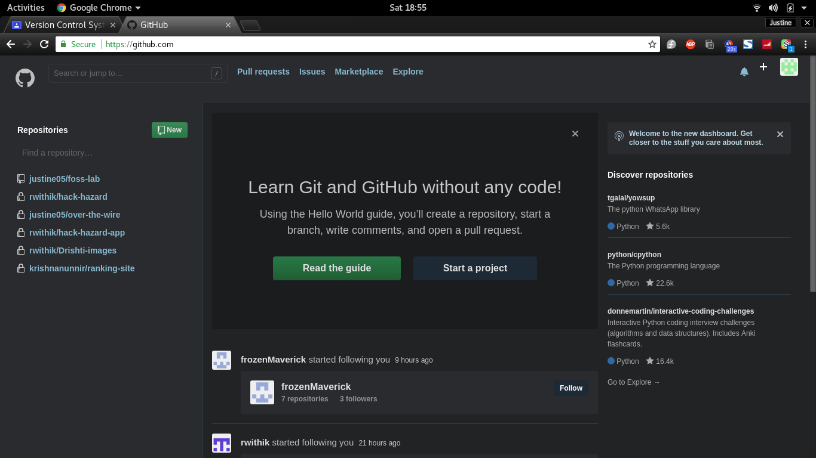
You can create a new GIT repository by clicking the ‘New’ button just beside the repository column on the left hand side

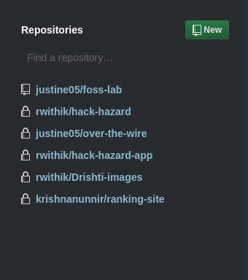

Now you can enter the repository name, its description and also select who are allowed to see your repository.

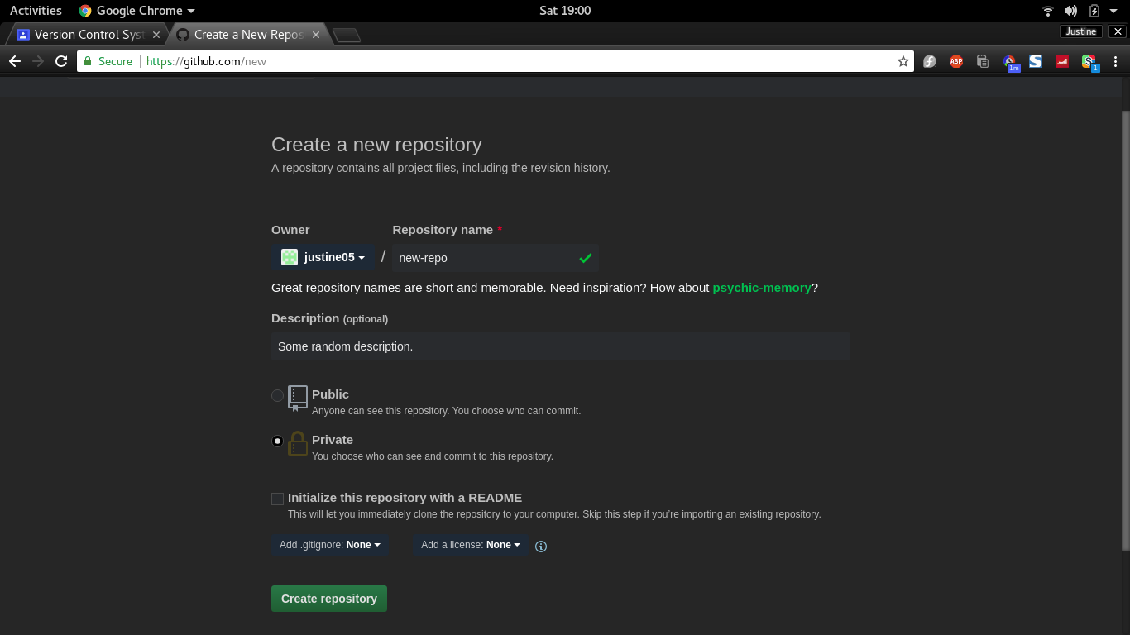

Now click the green ‘Create Repository’ button to finish the process.

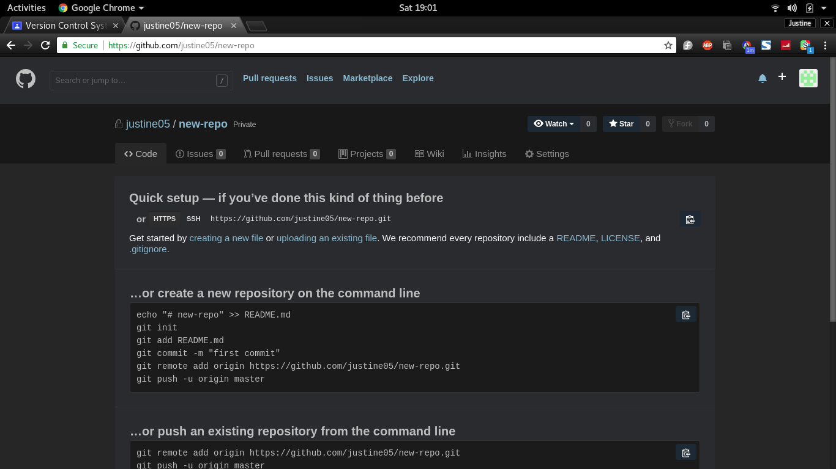
Now you have set up an Online Version Control System.

2. Checking out a repository.

You can clone other GIT repositories that are either public or shared to you using your terminal. But before that you need to set your identity.

This can be done as follows:

Setting up user-name

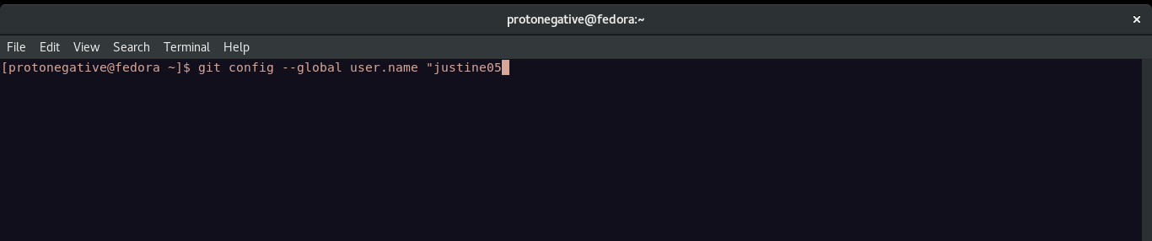
Setting up email-id

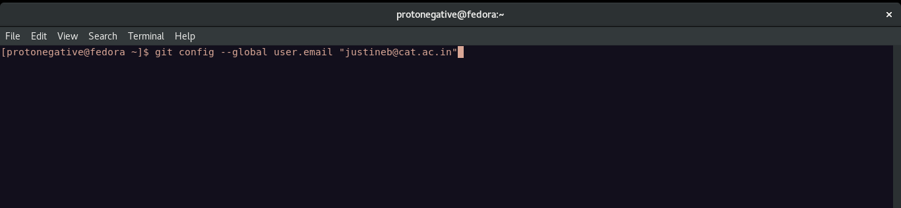
Now you have done the one time initial setup of git.

Suppose I want to clone the following git https://github.com/rwithik/hack-hazard-app .

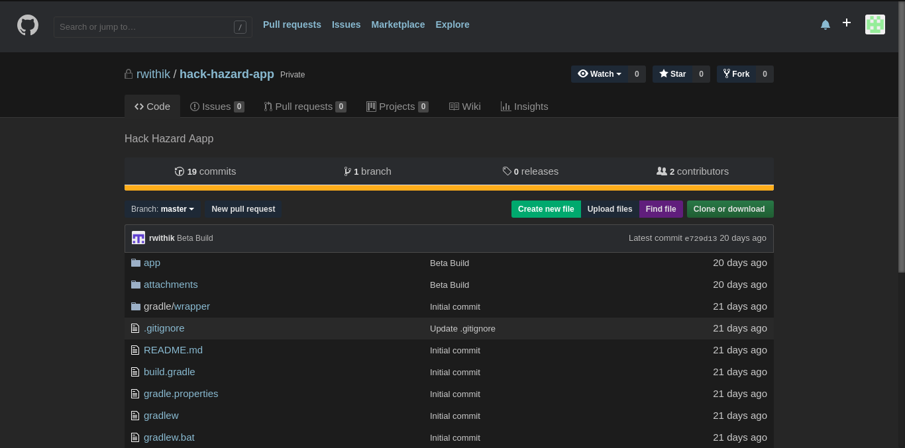
You can clone this repository using the following steps:

Get the repository’s web URL i.e https://github.com/rwithik/hack-hazard-app.git in this case.

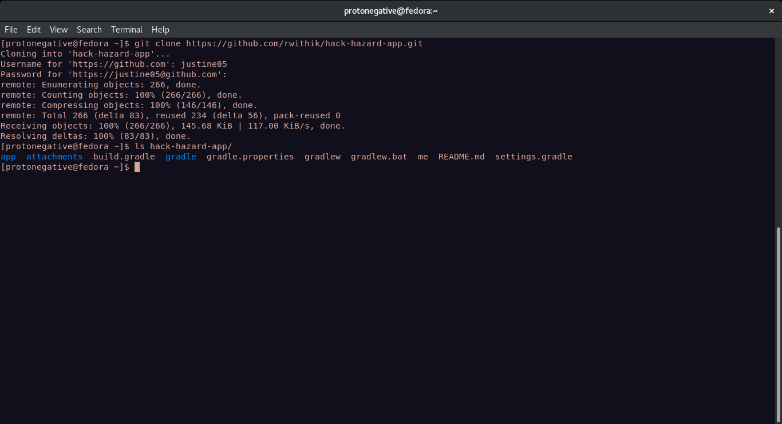
Type the above commands to make a local copy of that repository.

3. Adding content to the repository.

A local repository can be made git compatible using the command git init.

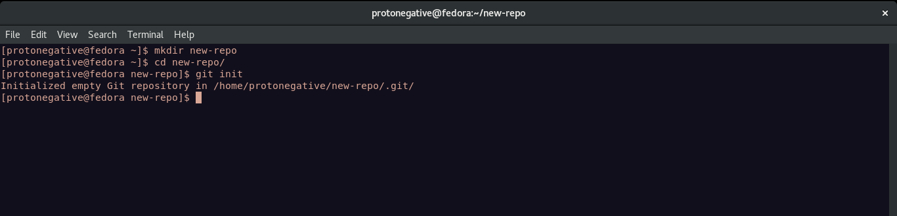
A locally made file (here file.sh) can be added to the repository using the push command. But before that the file should be made track able and put to the staging area

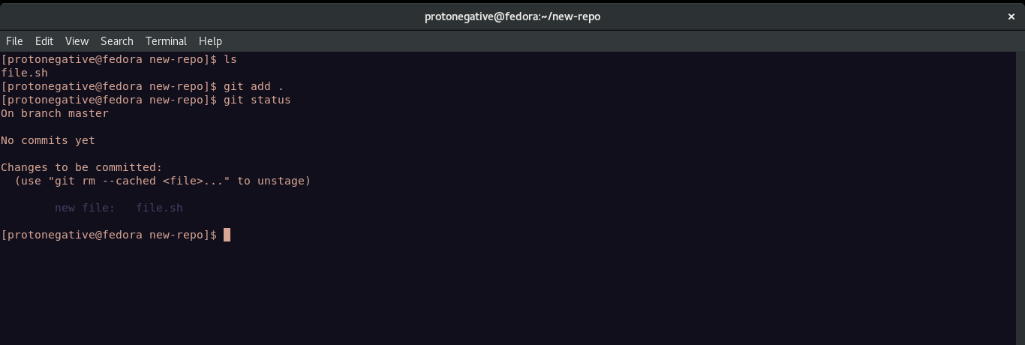
Now the file is tracked.

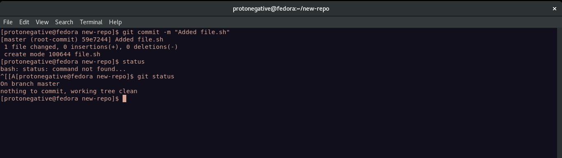
Now the file is in the staging area.

Now connecting the local and the remote repository.

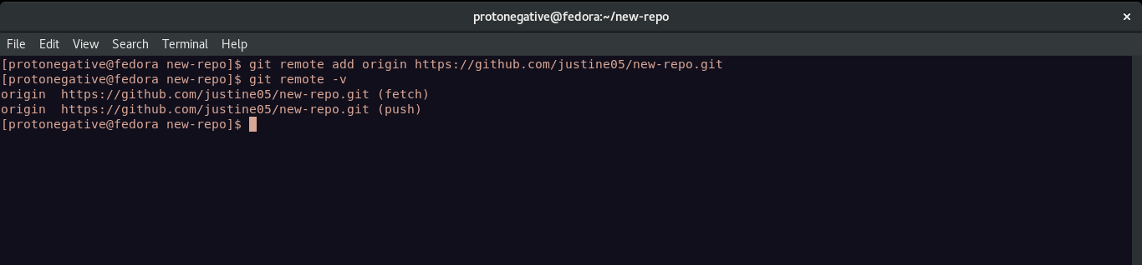
Now this file can be pushed into the local repository using the push command.

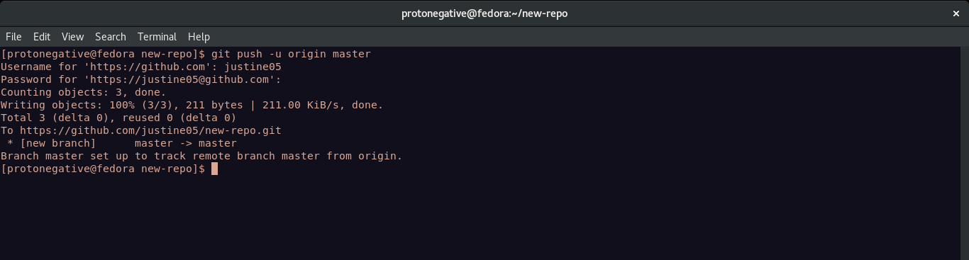
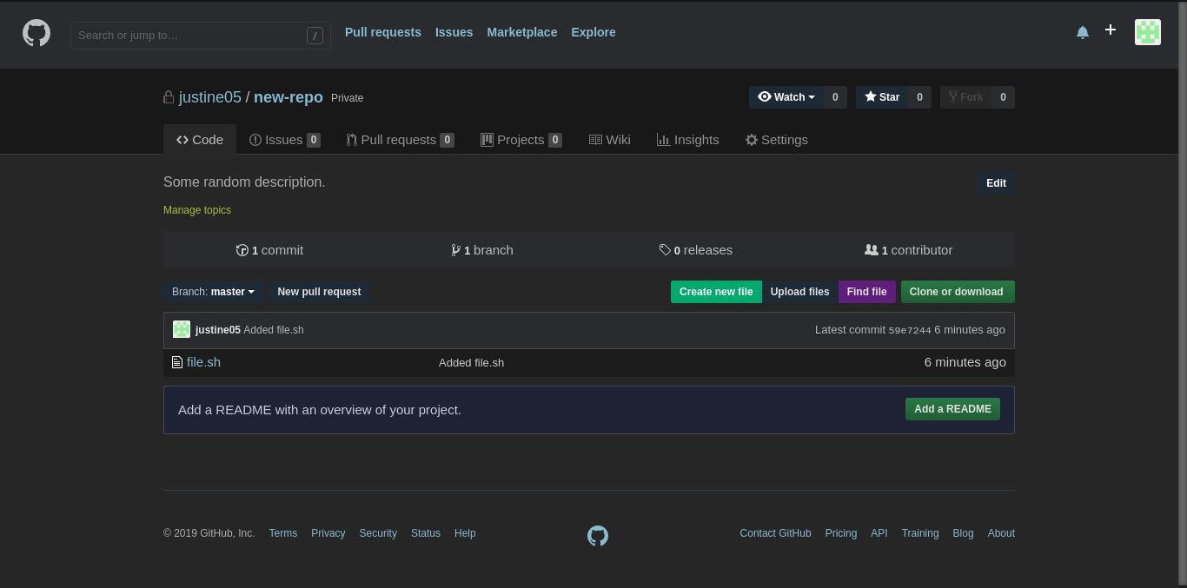
Hence the file is successfully added to the remote server.

4. Committing the data to a repository.

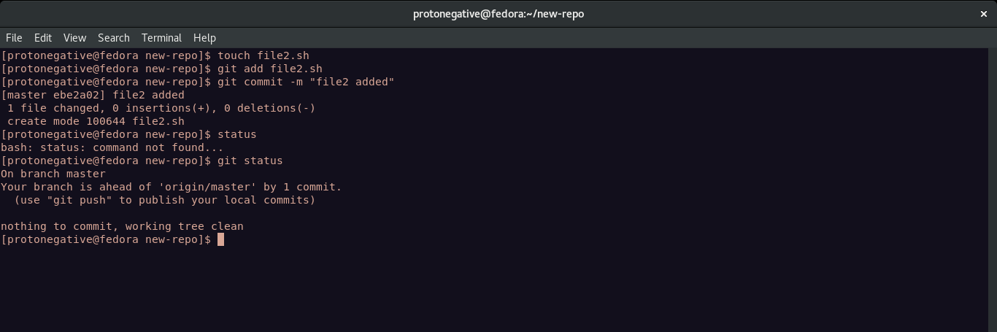
A new file file2.sh is made and is committed. Now pushing it to remote repository.

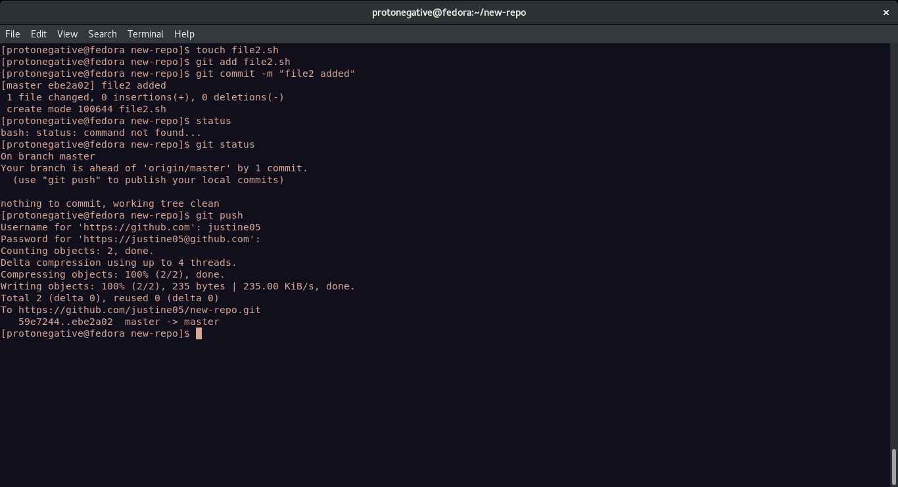
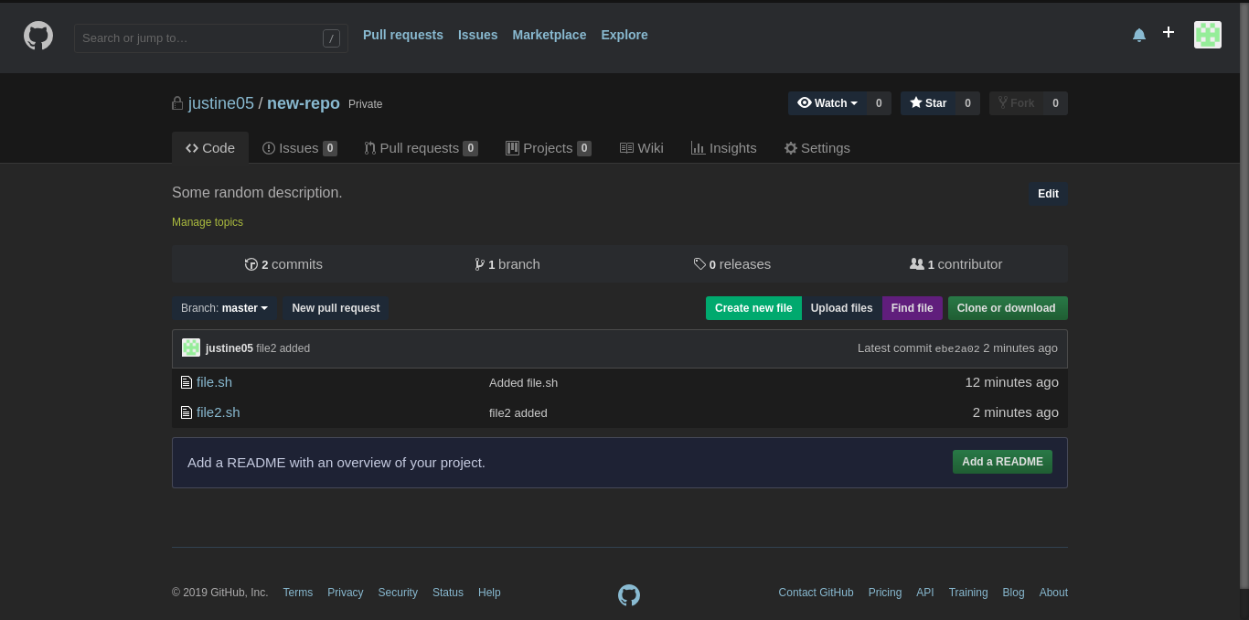
Hence the file has been successfully pushed with the commit message.

5. Updating the local copy.

When a new file is added to the remote repository using github or another contributor, the local repo should be updated using the pull command.

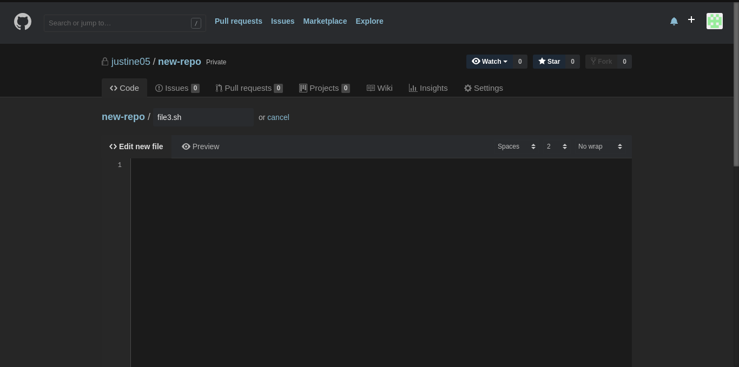
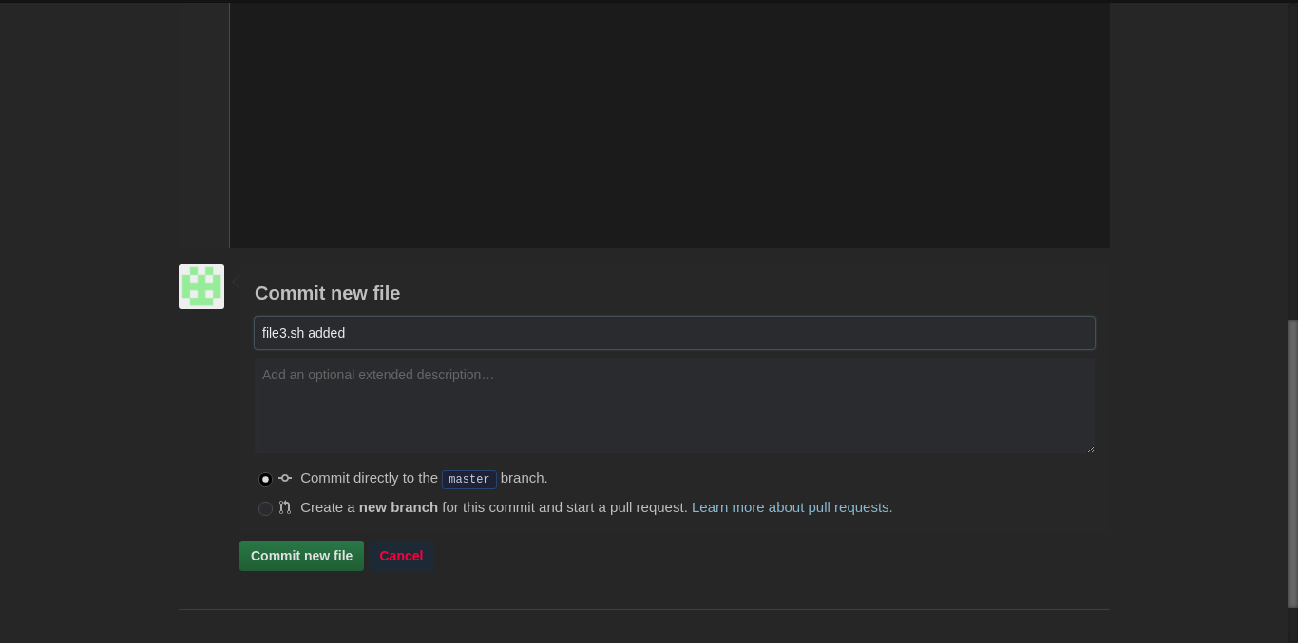
Creating file3.sh online using git.
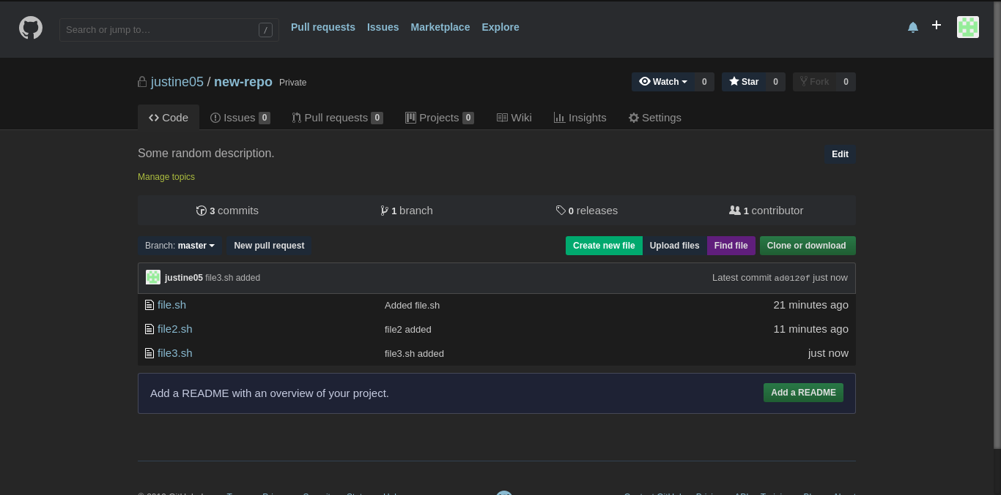
But our local repo is not updated.

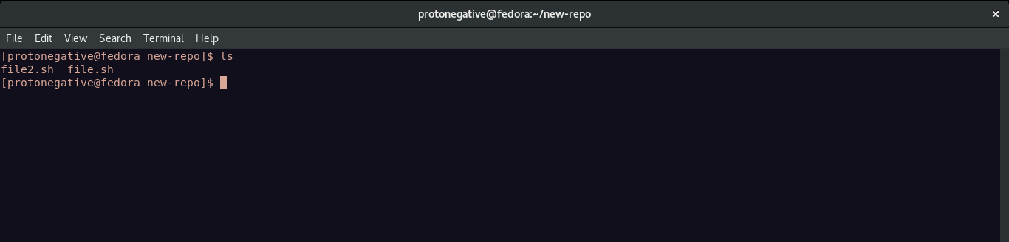
Hence we use the git pull command.

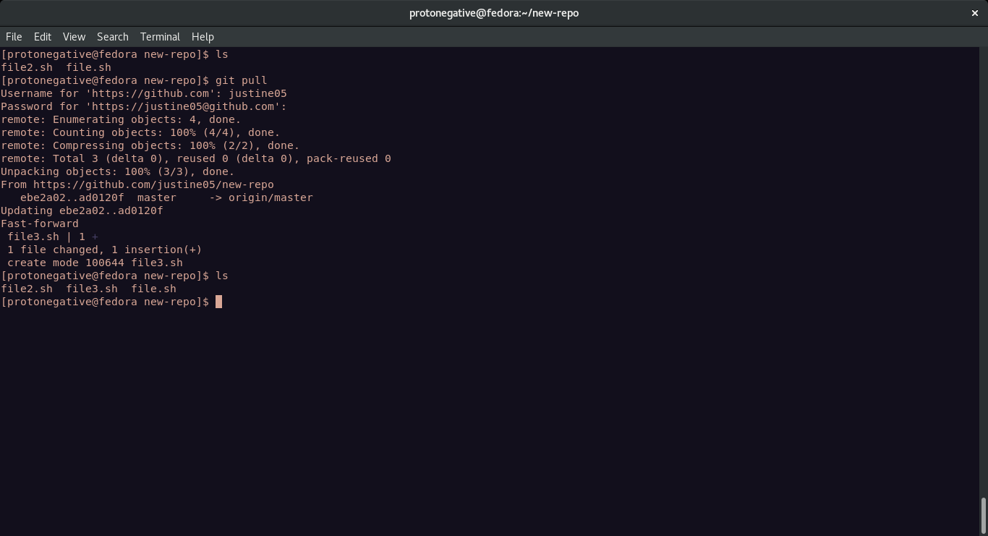
Now file3.sh is available in our local repository.

6. Comparing different revisions.

Different revisions can be compared using the log command.

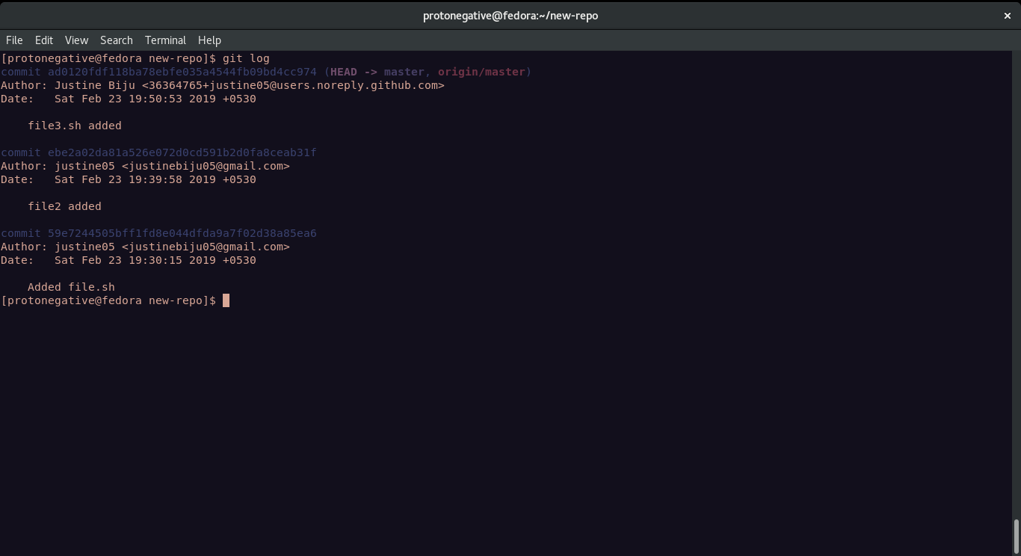
Here list all the three commits I’ve done to ‘new-repo’.

7. Revert

Now I want to revert to the second commit where file3.sh was not present.

So we take the commit id and use git checkout.

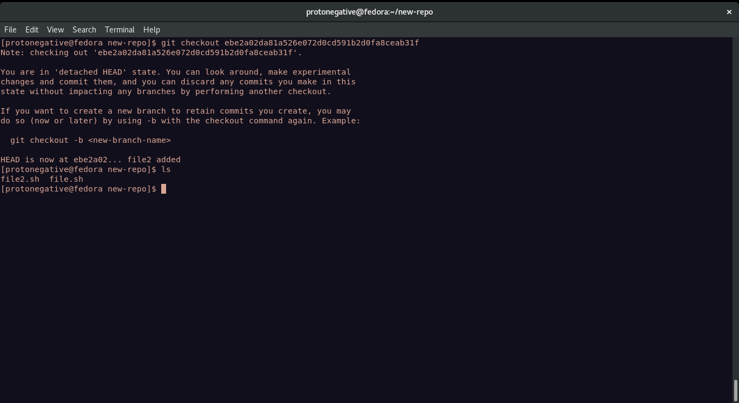

Now we can see only two files are in the local repository.

8. Conflicts and conflict resolution.

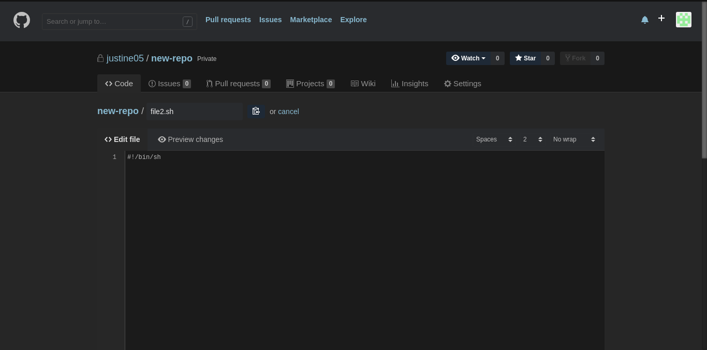

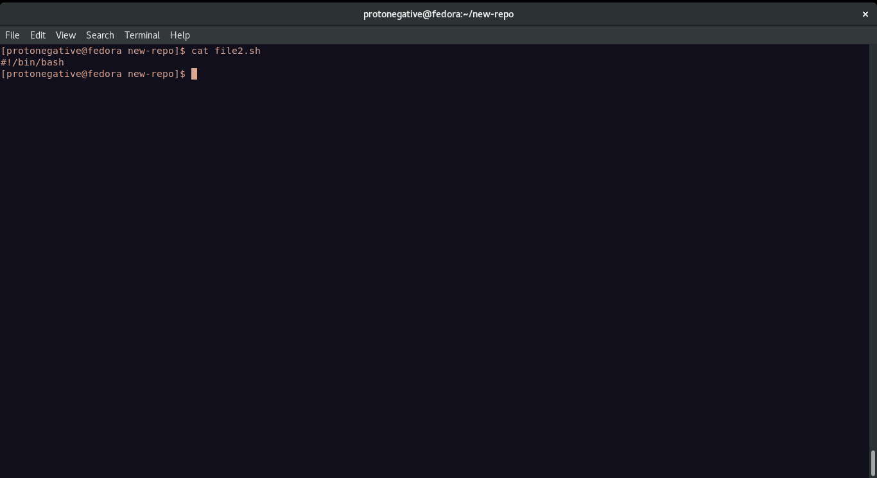
From the above two screenshots the content of file2.sh is conflicting hence pulling file2.sh to local repo will cause a merge conflict.

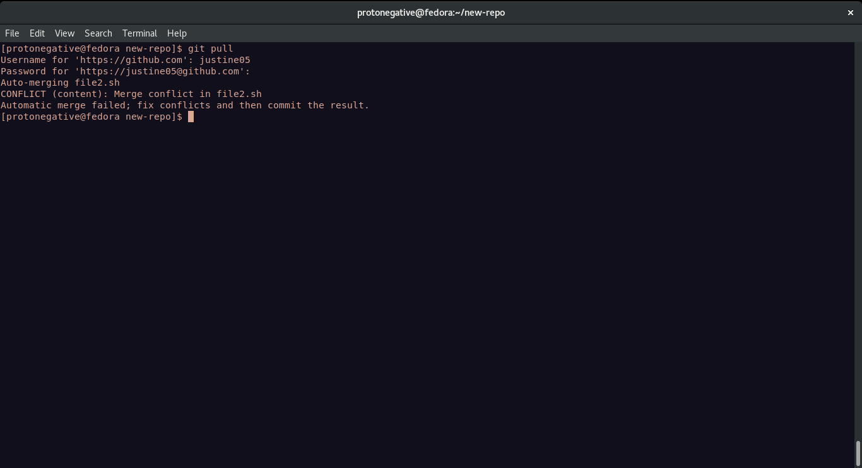

And hence the file shows the following.
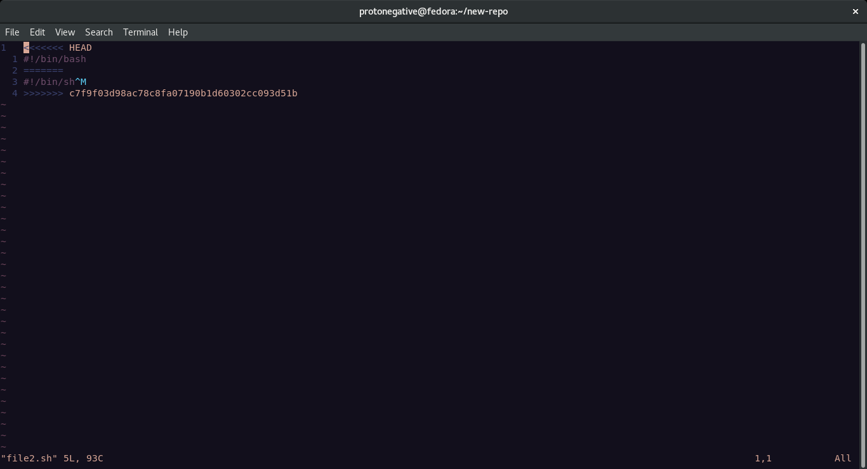
Now select which line do you want to keep and push again.

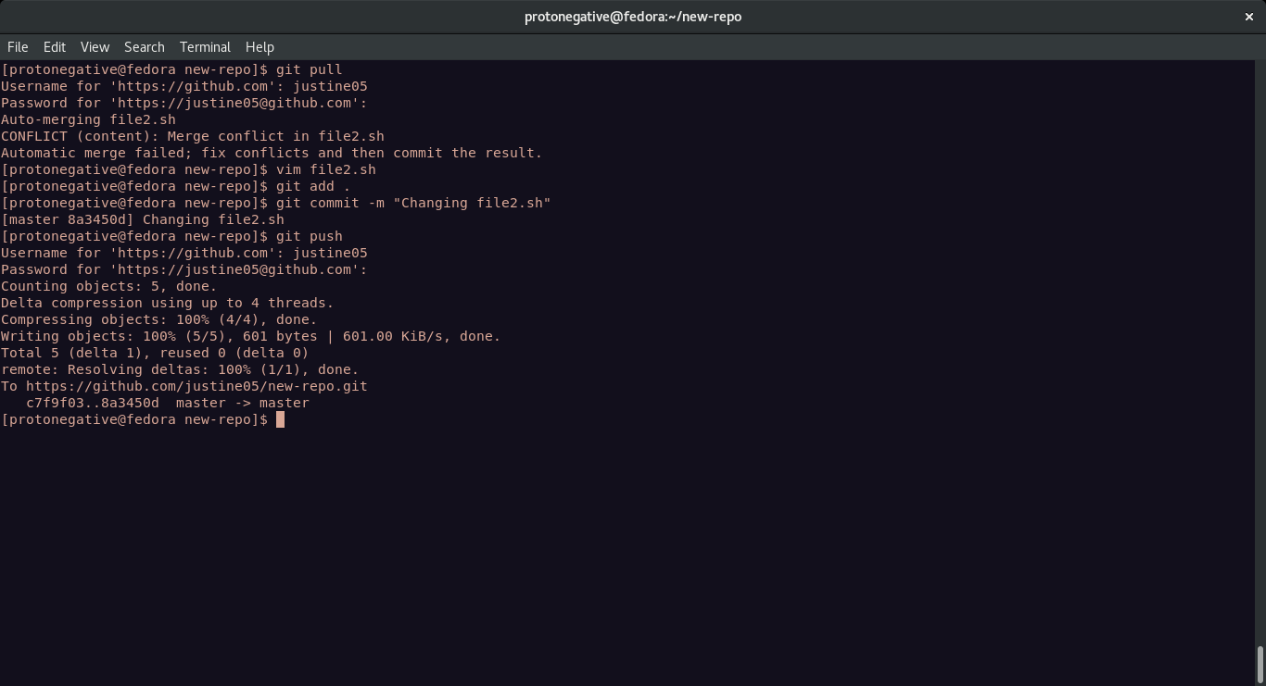
Hence this merge conflict is solved.

Result: Understood how to set up and manage a GIT repository.
---------------------------------------------------------------------------------------------
eof
---------------------------------------------------------------------------------------------

